Keywords:
web development Dubai, web development agency Dubai, web design agency Dubai
website development Dubai
Meta Description:
Learn everything related to web development services in Dubai, UAE, in detail. From critical roles to selection of the right agency, everything is covered.

An Ultimate Guide to Web Development Services in Dubai, UAE
To be relevant in today’s market, it is very important for any business to have a good web presence. This is where web development comes into the picture. Web development services in Dubai support brands by offering them a medium for communication with consumers and optimization of their processes.
As Dubai is one of the promising lands in terms of innovation and technologies in the UAE region, choosing appropriate web development services can highly affect your business outcomes. In this guide, we will provide information on some of the web services in Dubai and discuss other things that should be avoided to make the journey to website development successful.

Basic Understanding Web Development Services

Web development refers to the technical and creative processes used in the development and management of websites. It is a multifaceted process that has several levels, and each of them is crucial for accurate and SEO-optimized websites.

What does Web Development Services mean?
Web development services involve the creation of websites through designing and phase of implementation associated with website development. These may include creating ordinary websites where there is only text and links or graphics, simple to complicated 2-tier or even n-tier, multi-tier web applications. Concerning web development, there are several aspects that are quite significant, like design, content development, security and optimization.

The Significance of Web Development Services in Dubai:
Web Development is all about making a unique and attractive-looking website. Most importantly, web development makes the web page easy to use and able to promote itself to customers. In Dubai, which symbolizes innovation and development, web development services must follow the tendencies of the IT industry and meet the needs of international clients. Web development service is denoted with different responsibilities like escalating brand recognition, improving the usability of the website, and embracing the latest technological advances.

Importance of Selecting the Right Website Development Services in Dubai

The selection of the service provider is very important when it comes to finding the best web development in Dubai. The availability of competition forces the providers of the services to make their services available, but not all are efficient or effective. If you decide to collaborate with a professional web development company in Dubai, you must know whether the agency you are going to select fits perfectly the specific requirements of your brand.

The Critical Role of Web Development Services:
In the current competitive environment of Dubai, it is crucial to build a business that has a powerful online profile. Web development services are very crucial for brands that want to expand their client base, create customer loyalty, and increase sales through the Internet. Moreover, an efficient website can be an effective marketing medium because it provides businesses the ability to advertise their products and services to their liking. Let’s discuss the critical role of web development services for better understanding and more clarity.

Front-End Development
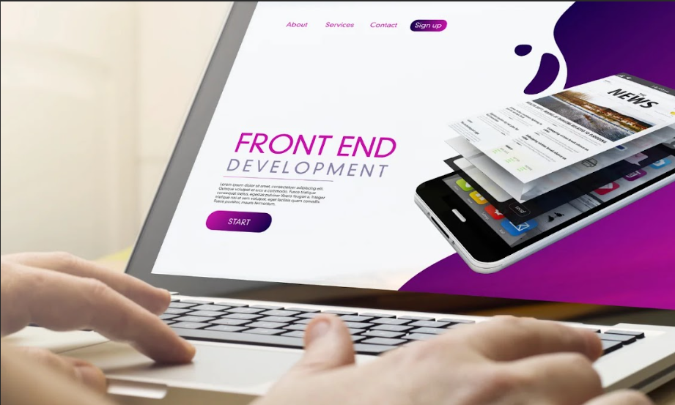
Front-end development is part of the process that deals with the front end and the overall look and feel of the whole website. It is crucial as it deals directly with the user who uses websites to get information or to engage in e-business.

What Includes in Front-End Development?

Front-end development refers to activities involved in designing or developing what appears and is seen by the user of the website. This comprises the website architecture and design and the engagement functions that enrich the aspect of utilization. Front-end developers have the responsibility of making a website attractive and optimal for use across different devices and browsers.

Technologies Used in Front-End Development

HTML and CSS, and Basic and advanced JavaScript are the core technologies that are used in the front-end development process. HTML contains the layout and organizational format of the website, while CSS addresses the aspect of the design of the views. On the other hand, JavaScript provides interactivity and dynamics to a website. In conclusion, these technologies help maintain high usability of the interface between the application and the end-user.

Importance of Aesthetics and User Interaction

The concept of aesthetics used in front-end development plays a critical role in making user experience more credible. The phenomenon of aesthetics building makes users' experience more appealing and potentially improves the engagement level. On the other hand, user interaction makes a website easy to navigate and easy to use. Strategic front-end development involves making sure that the users get what he or she wants in as short a time as possible.

Back-End Development
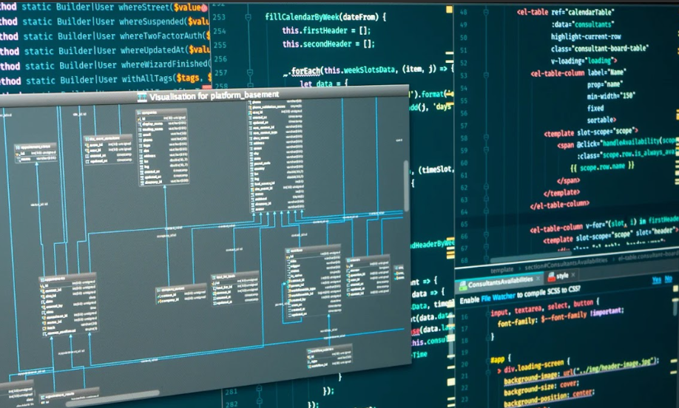
Back-end development is one of the key components of the development, which lies behind the scenes and is immensely important for the convenient work of a website.

Overview of Back-End Development
Back-end development entails working on the website's back-end operations by handling the server, working with a database and writing special programs. It necessitates that the website operates as it should so that it can perform the duties of data processing, storage and demand retrieval. The main work of back-end developers is mainly in designing a well-structured website that is efficient in its execution, with prime responsibility for the efficient performance of the website.

Key Technologies and Programming Languages
The back-end technologies and web programming languages comprise PHP, Python, Ruby, Java, and Node.js. These languages and technologies depend on the nature of the project and deal with issues of scalability, specific performance, and security. Sophisticated back-end operation enables the site to handle numerous visitors and improve the experience of visitors effectively.

Supporting Functionality and Data Management
Working on the back end is an important variable for maintaining the operation and administration of a site. Concerning importance, it guarantees the availability and content integrity of the data it stores and processes, as well as retrieving it at an optimal time. A good back-end design enables you to incorporate other elements and services, such as user authorization, payments, and content organization, in the development of a website, ultimately making it more functional.

Full-Stack Development

Full stack refers to the combination of both front-end and back-end, which is a favorable approach to web development.

Overview of Full-Stack Development

Full stack developers have a versatile knowledge of the front and backend of the web development process, so they can work on any part of the project. The process of full stack development involves creating the graphic user interface and programming functionality as well as handling all server-side activities, offering a one-stop-shop web development service solution.

Advantages of Full-Stack Development

It is clear that the stack developers have some benefits in terms of flexibility and management of wide operations. It can be implemented on all the layers of a particular website, and it is fully integrated with the front end as well as the back end. Full-stack development also comes with more options when it comes to controlling all the layers of a website’s functionality. Moreover, full-stack development also provides developers the ability to change different aspects more easily.

Growing Demand for Full-Stack Development in the UAE Market

The survey on demand reveals that the requirement of having full-stack development in the UAE market is rising dramatically. With an increasing number of businesses joining online, there has been the need to have developers who are able to handle both front and back end. Full-stack developers are particularly desired for their capability to provide an all-in-one solution encompassing both the front-end and the back-end that are in demand in Dubai and other parts of the world.

Common Pitfalls to Avoid When Engaging Web Development Services
Here are some common pitfalls you need to avoid when you are going to engage with website development services in Dubai. This way, you can make a decision that can help your business in a better way.
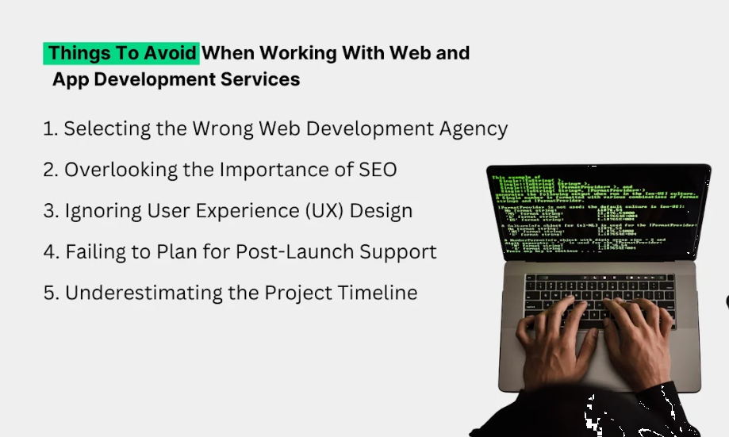

1. Choosing the Wrong Web Development Agency

Why It’s a Concern?
Generally, choosing an improper web development agency in Dubai may put quite a dint to the result of the project. There is a likelihood that the agency may not understand your vision and, therefore, deliver a poor outcome that does not address your organizational goals and objectives. It implies that the wrong selection of a web development Dubai agency can lead to increased cost, time consumption and bad business relations.

Potential Risks and Financial Implications:
- Sustainability Costs: Many agencies lack proper planning and experience; therefore, they cannot estimate expenses effectively.
- Overcoming Delays: This comes as a result of either misunderstanding or inexperience, thus slowing down delivery.
- Quality issues: Suboptimal work may lead to the creation of a website or app that does not interest the audience and can have various problems in terms of functionality.

How to Steer Clear:

Conduct In-Depth Research:
You must take time in the selection process to research the available agencies. When searching for agencies, it is important to look for ones who have considerable experience in your line of business. To know more about them, it is advisable to check their pages on social networks, read the reviews of their clients, and study-specific cases of their work.

Examine Portfolios:
How to assess the quality of previous work is to go through agency samples. Search for diversity in projects and determine whether the design aesthetic matches your organization’s brand. This will help you understand their level of experience and innovation to deal with your brand needs.

Conduct Interviews:
We highly recommend that in order to evaluate the performance of different agencies, you need to conduct interviews with them. While having discussions with agencies during the interviews or at the beginning of the project, it is important to identify your project needs, time frame and cost structure. After that, try to evaluate their communication and their eagerness to grasp your business requirements. One of the primary factors that a good website development Dubai agency must do is to be forward-coming on various recommendations and suggestions.

2. Neglecting the Significance of SEO

Why It’s a Concern?
Search engine optimization (SEO) is very important if you want your website to have a better ranking on search engines. Failure to consider SEO has implications such as low rankings, decreased traffic and unachievable business goals. Let’s have a look at the major concerns related to SEO.

Low Visibility:
Despite the creation of beautiful websites, if issues regarding SEO exist, it will be less likely that your website will be visible to your potential customers.

Less Traffic:
Less traffic is more apparent for an organization’s website when it ranks lower in search engine result pages. This leads to low traffic and little leads that can be generated more if traffic is high.

Competitive Disadvantage:
SEO can be a disadvantage if companies in Dubai do not embrace this strategy, as it places a company at a disadvantage compared to other competitive firms in the market.

How to Prevent This?

Integrate SEO from the Start:
Implement SEO themes from the planning process with no distinction. Localize with developers who grasp the basics of the SEO process and know how to use keywords, meta tags, and responsive designing.

Develop a Comprehensive Content Strategy:
Develop content that is relevant to the SEO objectives of the site. The pages and posts have to be valuable, relevant and informative to the audience and must integrate targeted keywords.

Continuous Monitoring and Refinement:
It is very important to track SEO performance analytically in a consistent manner. Keywords include, but are not limited to, organic traffic, keyword ranking, and conversion rates, among others. Analyze the results and make the required modifications concerning the SEO performance for effective SEO.

3. Disregarding User Experience (UX) Design

Why It’s a Concern?
User experience is very important to improve users’ retention rates and keep customers happy with your website. A poorly designed website not only causes the users to leave your page but also minimizes the chances of purchase.

How Poor UX Can Lead to High Bounce Rates?
- Poor Navigation: This makes it difficult for users to locate what they are looking for on the website, ultimately causing them to leave your website.
- Slow loading: Slow-loading web pages can be attributed to poorly optimized sites, and this makes the users leave your website before they read any content.

How to Ensure Quality UX?

Embrace User-Centric Design Principles:
When designing a website or a web application, ensure that you take into consideration the user's experience. You need to learn or understand about your users as they are. Gather and think from the user’s perspective to build easy-to-use interfaces.

Implement Usability Testing:
Engage the target audience to get results on the usability of the designs. Analyze the pages in the website and applications and understand the areas that require some changes. Done usability testing is to confirm that your designed interactive solution fits with the user’s expectations and works well.

Establish a Feedback Loop:
It is important to constantly gather feedback as well as to implement them for the improvement of your website. For a feedback loop, you can rely on surveys, conversations with the users, and analysis in order to collect data.

4. Overlooking Post-Launch Support

Why It’s a Concern?
Website maintenance is a critical aspect because, after some time, the website may develop some problems that require it to be fixed. Consequently, some technical issues may arise, the site may become less secure, and the usability may decrease, and this is all because of neglecting the maintenance of the site.

Risks Associated with Neglecting Maintenance:

Technical Issues:
Technical issues are basically recurrent glitches that affect the normal operations of the website and the viewing experience of visitors.

Security risks:
If the software of the website is not updated frequently, then it contains vulnerabilities that may expose your website to cyber criminals.

Lack of progress:
Neglecting maintenance over some time often leads to an inefficient design that hardly receives any updates. This lack of progress puts your website performance down and ultimately leaves an impact on the overall traffic.

How to Prepare?

Develop a Maintenance Strategy:
Describe a clear schedule to update and fix general issue fixes. This should involve modification of existing content, software upgrade, repair and other fixings for reliable technical services. This is important as it will ensure your website is functional and secure at all times.

Provide Team Training:
You need to ensure that your team is skilled enough to manage the website of your business after its launch. Here are some skills your team must possess:
- Updating Information
- Tools Upgradation
- Problem-solving Skills
- Ethical and Safe Practices
Make sure your team possesses all the appropriate skills mentioned above so you don’t have to seek assistance from outside.

Establish Responsive Support Channels:
You should establish a help desk to avail quick solutions in case of any complications. This can support teams, chatbots, and well-defined reporting channels when any kind of issue arises. Responsive support enables problems to be solved without much complexity for the users.

5. Underestimating the Project Timeline

Why It’s a Concern?
Another mistake that brands always make is underestimating the duration of time needed to execute a web development project. Deciding on unrealistic timelines means that the work is hurried, and the final quality of work that is produced is normally not satisfactory.
Haste in software development is one way of causing problems ranging from the overall appearance of the website to the overall functionality of the website. This ultimately affects the user and, consequently, the success of the project.

Mitigating the Effects of Bad Timeline Management on Project Efficiency
Whenever given timelines are hard to meet, it is evident that the quality of work produced will not be good. Developers may compromise, resulting in issues like applications with multiple faults, performance that is not at its best, and applications that have areas that can be prone to exploitation. Also, having less time also impacts the performance of the team, increases rigidity and reduces work effectiveness due to fatigue and lack of innovative ideas.

How to Manage Effectively?

Set Achievable Goals and Objectives:
The goals and objectives formulated should be realistic in the light of the project plan proposed to achieve the specific project goals. Consult with your development team to determine the challenges that are likely to be encountered and agree on the amount of time required to develop, test and edit the site.

Update frequently:
Make it a practice to update all the concerned parties about the progress being made in the project. This has a positive impact on the way expectations are managed, and in case of any antecedent delay, the management can intervene at the right time.

Mitigate Scope Creep:
Avoid cases where the range of what should be completed is not well-defined at the outset, and any adjustments are not agreed upon and well documented. This approach also assists in keeping the target in sight and properly aligning the project.

Essential Tips for Hiring the Best Custom Web Development Services Agency in Dubai

Identify Your Specific Needs
To start with the selection process, it is highly recommended that you should be clear with your needs. The objectives involve knowing your goals and desired end results to make it easier for you to select a web development Dubai agency that meets your needs.

Define Your Objectives:
Define the objectives that you hope to accomplish with the overall web development. Ask yourself. Do you need a new website for your new product or to implement hi-tech solutions? This will save you time in searching and will also help you to explain your requirements in a better way.

Determine Your Budget:
You must appreciate your finances, which may limit the amount of exercise needed to get better outcomes. Have a clear and quantified economic plan of how much would be spent on designing, developing, testing, and maintaining such systems. This will enable you to make distinctions regarding agencies that you can afford.

Assess the Need for Advanced Technologies
Self-ask if your project needs AI/ML blockchain or any other type of development that is considered high-end or complex. These are aspects that should be identified early enough so that you can identify a website development Dubai agency that is capable of fulfilling the needs.

Conduct Thorough Research and Create a Shortlist:

Look for Positive Online Reviews
Reputation plays an important role in the industry. Check recommendations and comments to determine the number of successful performances made by the agency and customers’ feedback. It is important to search for consistent praise in areas that appeal to you, like quality, reliability, and communication.

Analyze Their Portfolio
The next step when choosing an agency is to look at the various projects the agency has handled in the past with a view to evaluating the quality and relevance of the projects to your project. You can assess the effectiveness of a company by its experience in similar projects that were successful in delivery.

Seek Recommendations:
Question the previous clients and some other contacts that work with the agency. Recommendations can be extremely helpful and will enable you to hear firsthand and experience the different things as they are.

Evaluate Their Expertise and Experience:
Once you have cut down your initial list to those agencies that you are most interested in, you should focus on researching the specifics of agencies’ work.

Assess Skill Levels:
Make sure that the agency’s team has the skills of the technical nature needed for your project. This ranges from the main programming languages, and frameworks applicable to the particular method used as well as the tools that are employed in the process.

Check for Relevant Industry Experience:
It helps you have a good awareness of the specific industry you are in. We also recommended you work with an agency that specializes in your industry.

Ensure Team Compatibility
Assess whether the agency’s team is suitable for your project based on the goals you have in mind. In most cases, a cohesive and synergistic team would always be in a position to provide results that best fit your needs.

Assess Their Communication and Project Management Skills

Identify Communication Channels:
It should be important to understand how the agency communicates with clients. Effective communication is critical as it helps to respond to challenges as soon as possible in coordination with the other parties involved in the project.

Review Project Management Tools:
Find out whether the agency uses specific tools for project management. In particular, project managers' tools are very necessary in terms of tracking progress and partnership. Moreover, such tools also prove useful for enhancing project productivity and openness.

Final Thoughts:

Overall, web development services are crucial in enabling businesses in Dubai to have visibility on the Internet. Choosing the appropriate web development agency in Dubai is one of the toughest decisions that can greatly affect the existence of your business online. By understanding your users, focusing on outcomes, and involving SEO in the project as early as possible, your web development goals shall be not only achieved but surpassed, putting you in a solid position within the Dubai market.

